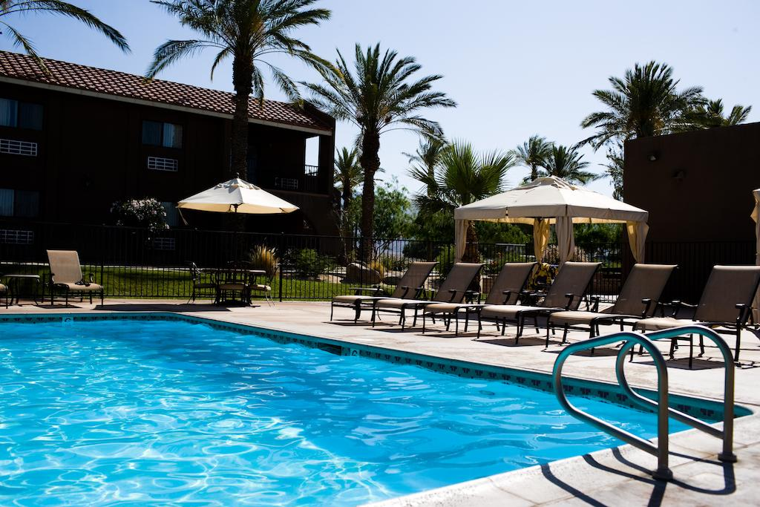

**Resort Reservation System (RRS)**

**Members**: Michael Yee, Tony La, Steven Duong,

Thuan Chau, Ching Yi Lui, Shawn Chua, Alexander Giang

**Alternatives**

When searching for alternatives, our team decided to look for potential reusable sources on github.com. Our end goal was to create a reservation system for the Borrego Springs Resort but we figured that any type of reservation system would work with what we’re trying to accomplish since it should be relatively similar to ours. We ended up finding three potential alternatives:

Resort Hotel Demo - <https://github.com/Pixelsavvy72/Resort-Hotel-Demo>

Hotel Management System - <https://github.com/N3TC4T/Hotel-Management-System>

Hotel Management - <https://github.com/tugbadogan/hotelmanagement>.

Alternative 1: Resort Hotel Demo

Because our entire team ran the Windows Operating System on our personal computers, we used that as our platform to run on. It uses the .NET platform and SQL for its database. On the programming side, it’s coded in ASP.NET, C#, and Javascript.

This alternative had many positives about it. For example, there was already an account management system with the ability to create new User-level and Admin-level accounts and other modifiable settings. These two types of users could search for rooms and create a reservation as well. Boundary conditions for input values are in place with reservations such as with rooms quantities and dates. Overall, this gave us a great foundation to start with when it comes to implementing features. This covered thirty percent of our requirements in the case that there’s already a provided reservation and user system. Little tailoring is required to fit with our specifications. The site already provides a basic login/landing page as well.

With this alternative, we would have to update the framework of the website to fit our specifications, modify the reservations system so that there could be other types of reservations, and add a restaurant support system that we would have to develop from scratch. Unfortunately, there was minimal documentation in the code and there was no formal test software for us to use. It was unclear if there was any bugs or problems with the system. We did get it to compile, but ran into some issues and errors with connecting to the database. Due to this issue, we ended up not choosing this alternative.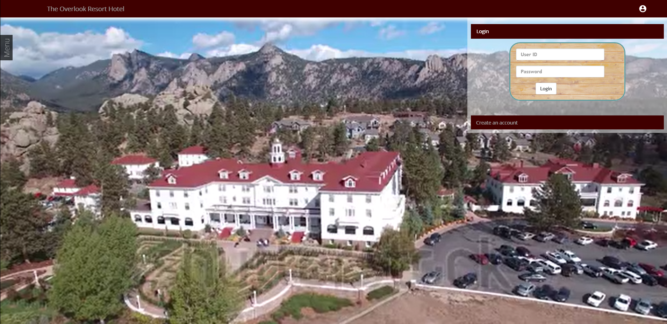

Alternative 2: Hotel Management System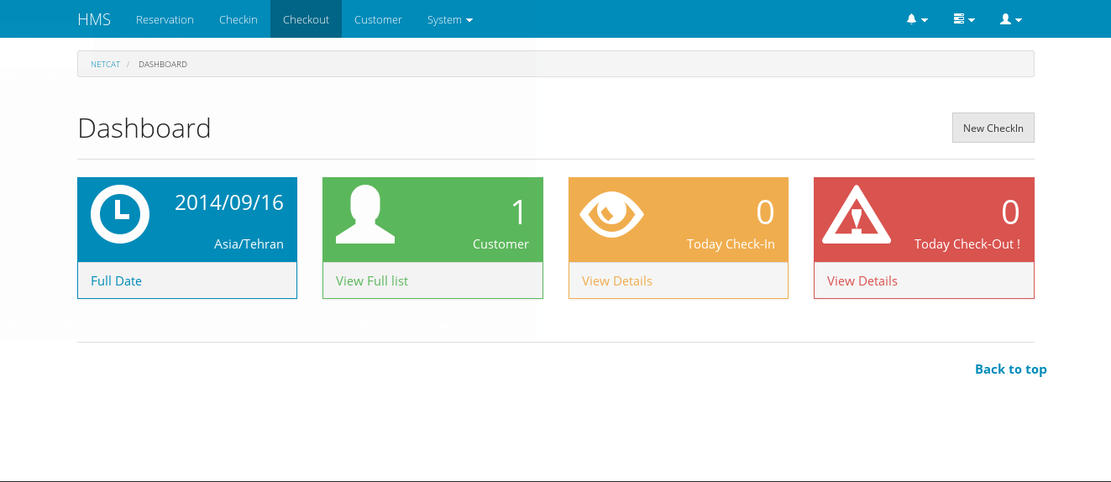

Our second alternative that we analyzed was the Hotel Management System. We used our own personal computers with the Windows Operating System for executing this reuse software. It uses SQL for its database, is coded in PHP, and uses the Codeigniter framework. This alternative would have been the one we chose if only we got it to run. There was no test software with this alternative so we tried loading it through an external software called XAMPP with an Apache-based host but ran into multiple errors. This software met approximately seventy-percent of our requirements. It contained features such as a user-level and admin-level account based system with registrations, logins with account validation, and individual dashboards. Users were able to book rooms, 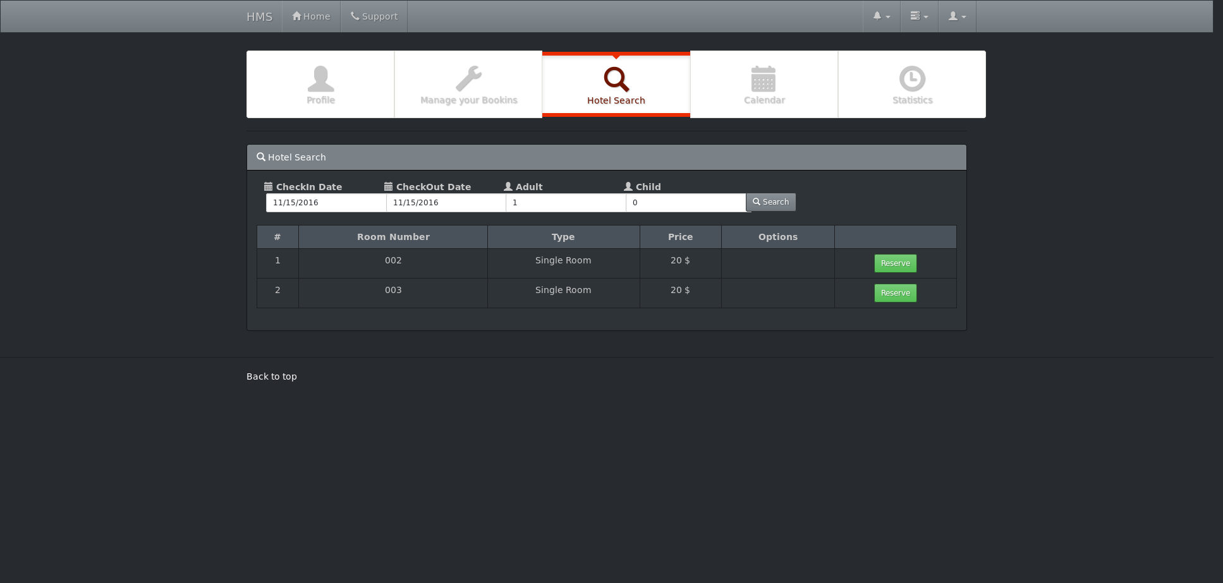

decide their check-in and check-out date, and view various rooms and room types. One feature that we planned to implement from here was an employee level account system, restaurant system, and an announcement system. Since we ran into multiple errors attempting to get it to run, we would have to do a lot of tailoring with software just to get it to run. Much of the time was understanding how the Codeigniter framework works, along with learning PHP and SQL which would have taken too much time for the team members. There was moderate documentation in the software but was of little use to us. There were no known lists of problems or bugs but what we know is that this software ran an older version of PHP while XAMPP uses that latest version, so some compatibility errors may have occurred. 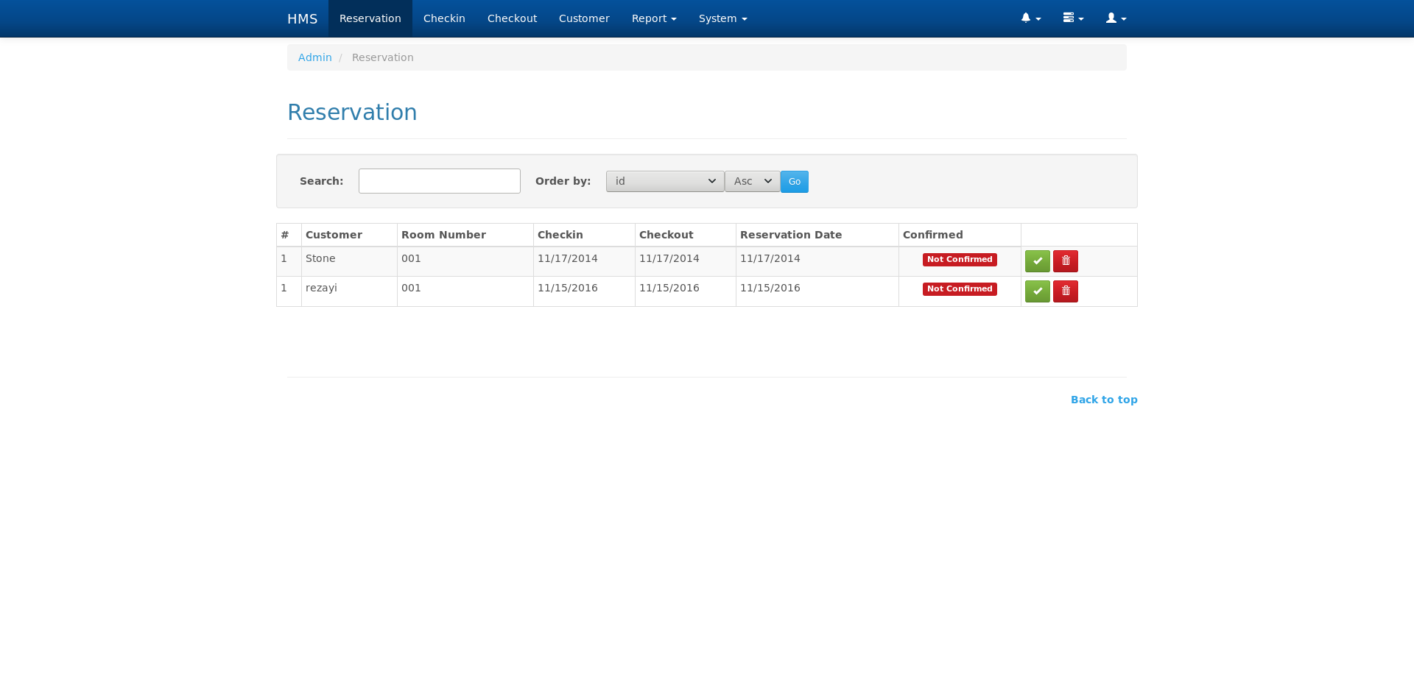

Alternative 3: Hotel Management

Our third alternative and the reuse software that we ultimately ended up choosing was the Hotel Management. Similar to the previous analyzed alternatives, we ran this software through our personal computers using the Windows Operating System. The Hotel Management uses the CodeIgniter framework, is coded in PHP, and uses SQL for the database. Like the second alternative: Hotel Management System, we used XAMPP to run this system and managed to get it to work without any errors. It met a good number of our requirements with a login system in place for users, room reservation and availability system, database, restaurant implementation and a dashboard. With this alternative, minimal tailoring is required and is only needed with adding different types of reservations, check-in/out functions, and a payment system if those were our desired features. Originally, we opted to develop additional software for a report system, online help function, tour and rental services system, and an announcements function but upon further analysis of this software, we found out that it was entirely centered around the employee. There were no customer-based features for the login, dashboard, and reservations so we decided to modify this alternative to implement those three features. Unfortunately, there was little to no documentation in the code, no test software, but there were documented issues on the github page which provided lots of help to us. We decided to go with this alternative because out of the three, we managed to get this to run without any issues.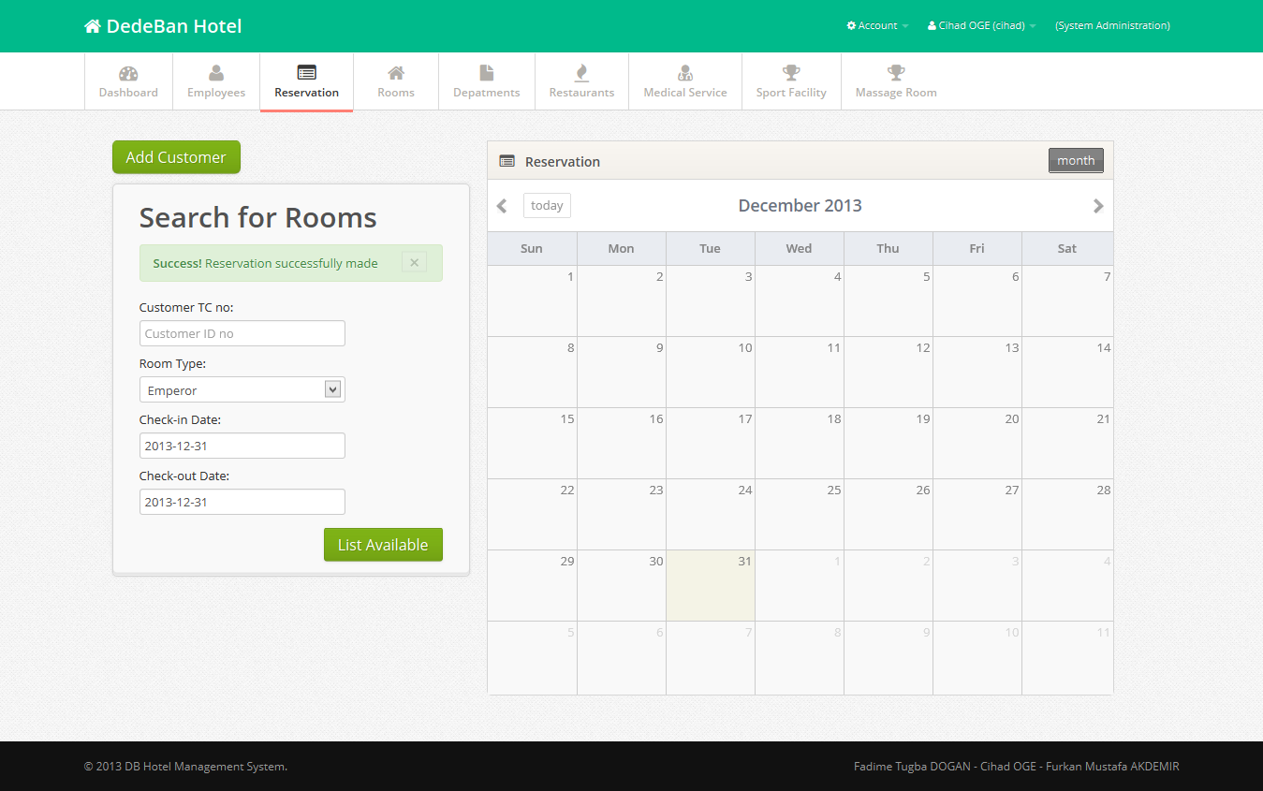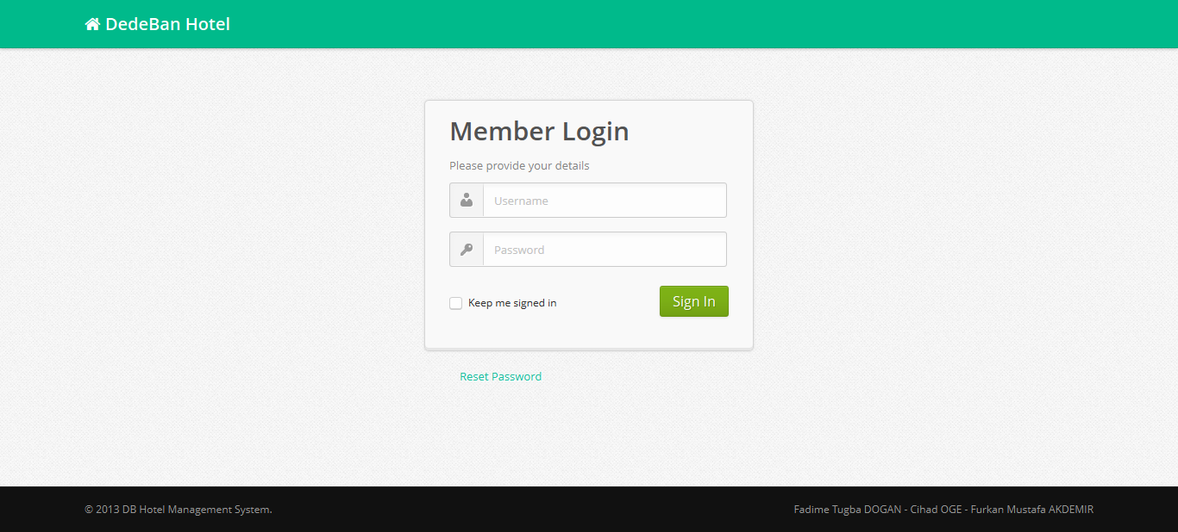

The features that were provided by our reuse software was a basic login system, the ability to create a reservation for a specific room with check-in/out dates, and a basic dashboard to work off of. Since this reuse software was entirely centered around an employee level system, we knew that we would have to modify these three components to fit with our requirements for developing a customer-based system: (1) where a customer could register for an account, (2) create their own reservations, (3) have their own dashboard. With the original reuse software, upon loading the website, the user was greeted with a simple login screen for employees. There was no landing page so we decided that we were going to have to develop that from scratch.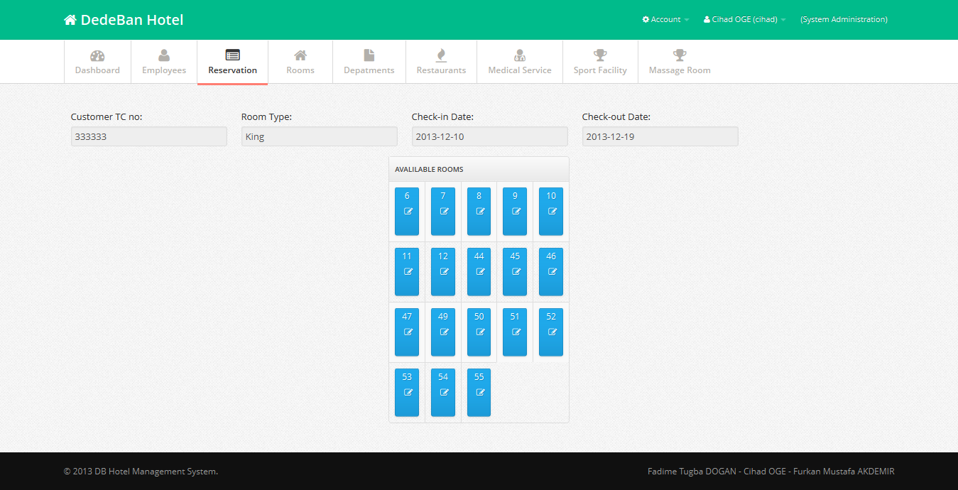

**Architecture**

In this project, we used the Model-View-Controller (MVC) architecture because of two main reasons. First, MVC has been widely used in developing many web applications. Second, the alternative we chose used the Codeigniter framework for PHP. This framework uses the MVC architecture and makes development and maintenance much easier. So in our final decision of the architecture, we selected the MVC architecture to make our development consistent with the reuse software.

Here is an overview about MVC. Model represents the data structure which contains functionality and interaction with a database such as CRUD. View displays what the user can see. The view file could be an entire web view or view fragment such as header or footer view. Controller serves as intermediate between model and view. Controller handles all http requests from web-browser, loads views, collects data from models (via model reading and returning data from database) . It also views (via post method in view form) and updates databases, and views depending on business logic and how the user interacts with the application.

Each new feature follows the MVC architecture. Some of the view files are shared and reused in some of the webpages for the new features, such as the header, containing all the tab buttons for the user to click or navigate through website, and footer of the website. We implemented new database tables and modified some constraints of pre-existing tables. Many models and controllers were developed corresponding to website navigation and the purpose of that web page, such as when a new user model needed to be implemented for the customer to login the website. To aid this, we added new customer tables.

Landing Page

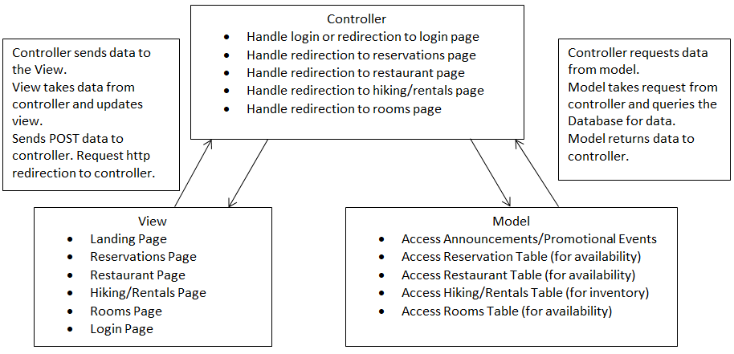

Dashboard

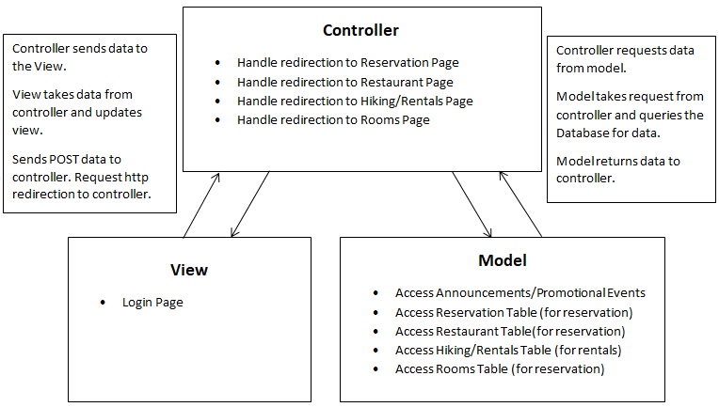

Reservation System

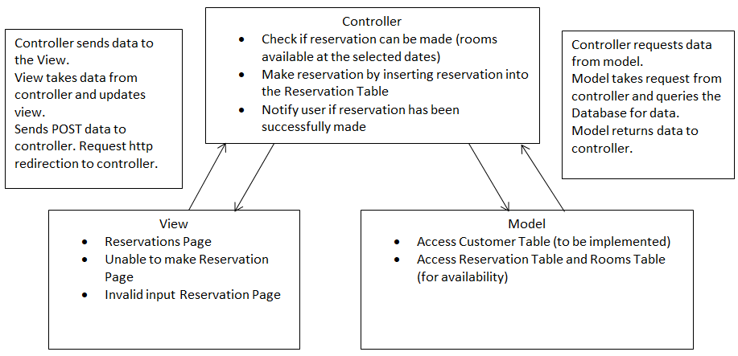

Customer Table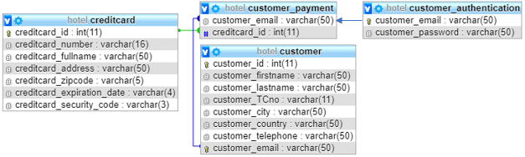

**3 Features**

The three features we selected were the landing page, customer dashboard, and the reservation. Before deciding the features for our resort, we had only two users/actors to start with, the employee and the customer. However, when deciding to include the landing page for one of our three features, a third one came, which was the visitors. The landing page contains information that would be available for the customers and visitors to see. This would allow the users to learn what is in the resort, what are the room types, restaurant, hike and rentals, etc.. The customer dashboard has the customer as the user, and this allows the customers to be able to see what they had reserved for their rooms, rentals, and/or restaurant. The restaurant was already in the alternative but it had some requirements that were missing and some that were not implemented well. Therefore, we had to hook it up to the database and add the reservation types -the prepaid reservation and the 60 days in advance reservation.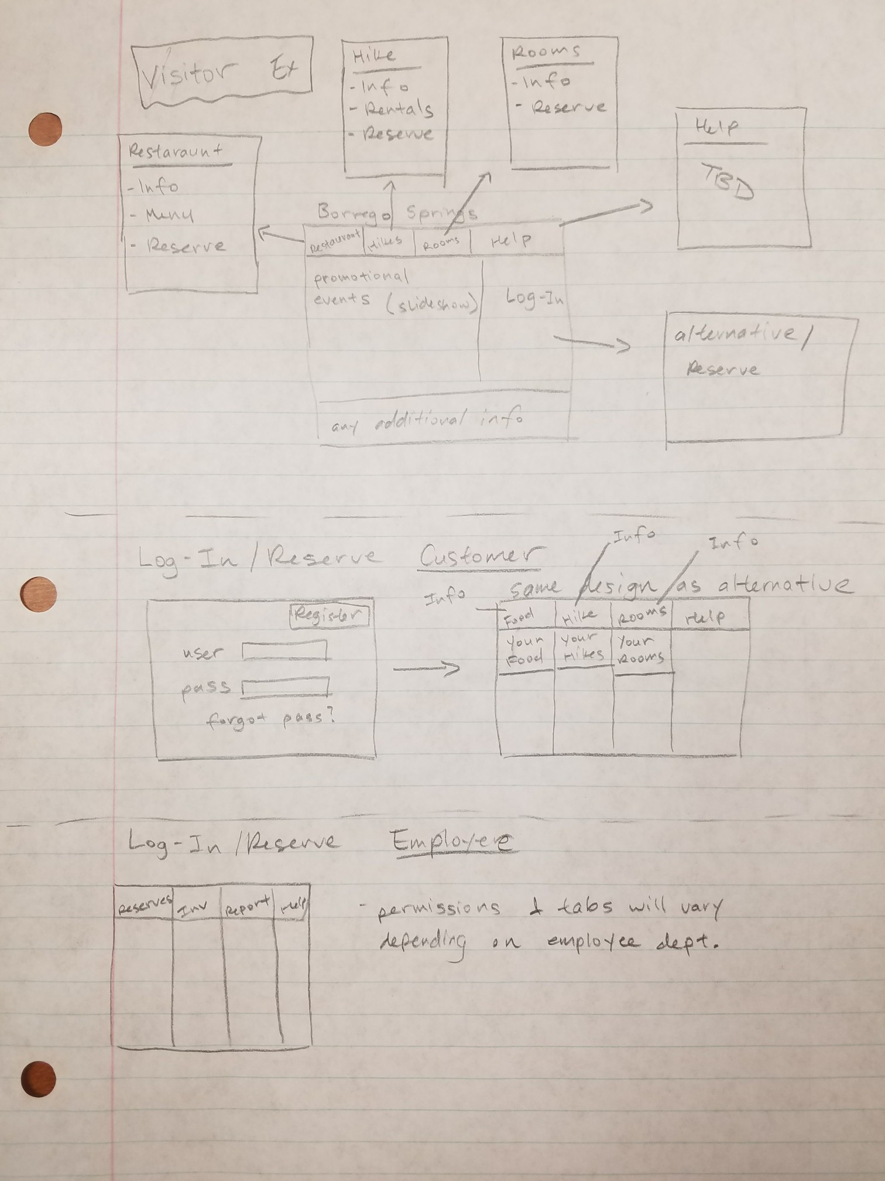

Landing Page: When we negotiated for the features, we wanted a landing page because it makes sense for a potential customer to visit and learn more about the resort before making reservations. As we were learning how the alternative worked, Alex did the initial design for the website as a whole. We were not sure what type of design the landing page should have, so Alex tried to model it after other hotel sites with simple UIs. Many of them had tabs that would redirect to each department with a login button on the side. In our case, that login button would redirect to the login page that was already implemented in our alternative. Just in case there was anything else we needed to add, additional info can be seen at the bottom of the design. 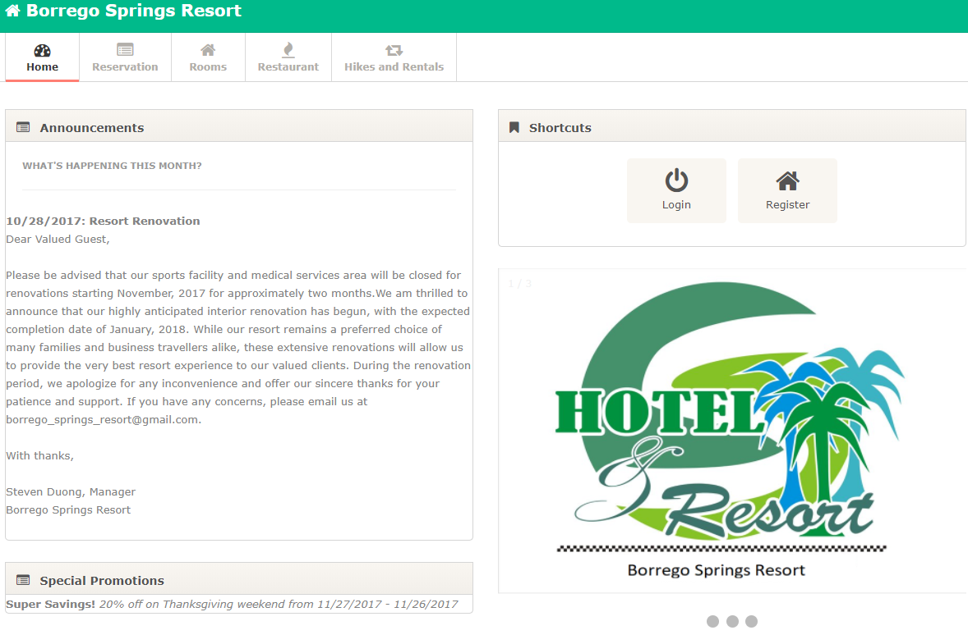

Alex was also assigned to implement it. Originally, he was just supposed to do a mock-up, but he realized that the page looked a lot like the employee dashboard, so he used the basic format of the employee dashboard provided by the alternative to make the landing page. Next, Thuan suggested that the team should keep the landing page and employee dashboard separate because customers should not have employee-access. With the XAMPP set-up, there would be 2 separate folders that lead to 2 different websites -- an employee website and a customer website. Since Alex implemented the landing page on a copy of the employee dashboard, he was not sure how to add it to a clean folder without all the necessary files. Michael was able to fix this problem. Alex also added the information pages for each of the other tabs, such as Hiking & Rental prices and Restaurant menu to make it more like an actual landing page. This was hard-coded though and should be implemented with the tables on future sprints. Steven also did some reformatting and added the special promotions and notices to make everything more aesthetically pleasing. This was a great example of our teamwork.

Customer Dashboard: With the original alternative that we selected, there was an employee dashboard feature in place that contained information such as current statistics, room availability, overall hotel income, etc. but these features are of no use to the customer. In our original mockup, we originally had a simple screen with shortcut buttons to reach other pages of the site. Upon development, we implemented the buttons within the header file in our software but the page itself felt too empty. Other pages of the site had access to the same header so the dashboard felt useless and we decided to add extra features to it. We felt that it was important for the customer to see what sorts of reservations they made themselves since there was no other system in place for it. From here, we decided that it was necessary for them to view their own restaurant bookings and tour/rental services purchases too. We didn’t implement the restaurant system or tour/rental service system but the option is there to implement it in future sprints. 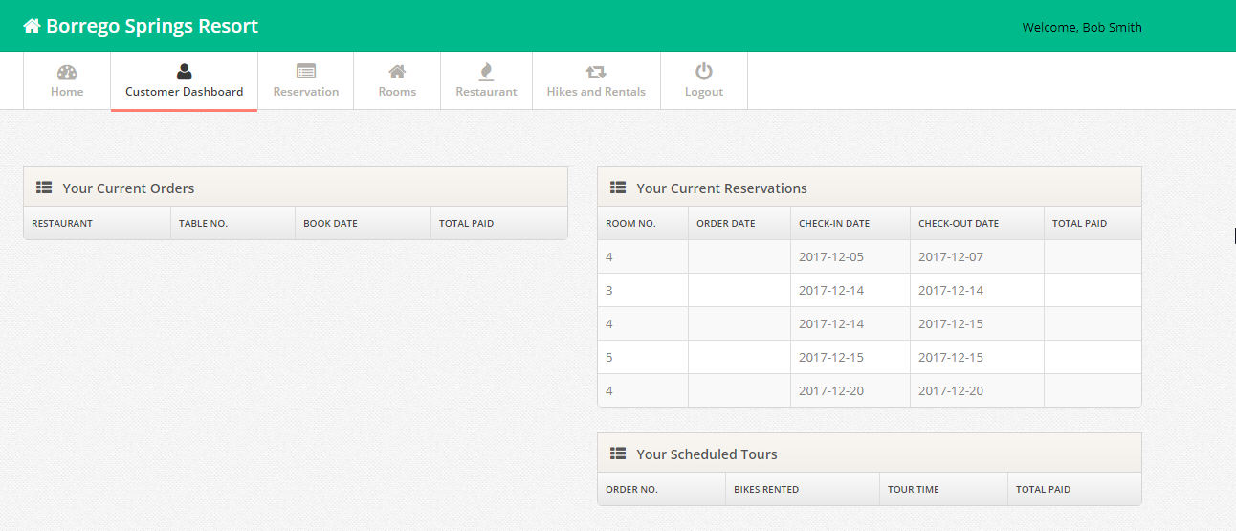

With the reservation table on the dashboard, a customer could view the room number they booked, check in/out date, and their order date along with the amount that they paid.

Reservation: We planned to have a three step process in the reservation page. The user can choose the room type and date first. Once they have entered those information, a pop up window will appear to show the picture and price of the room they chose. Then the users can choose the available room number, reservation type, enter the credit card number for the payment. After this, and when everything is entered correctly, a confirmation page will appear so they can review all the information before payment and redirect them back to the main reservation page.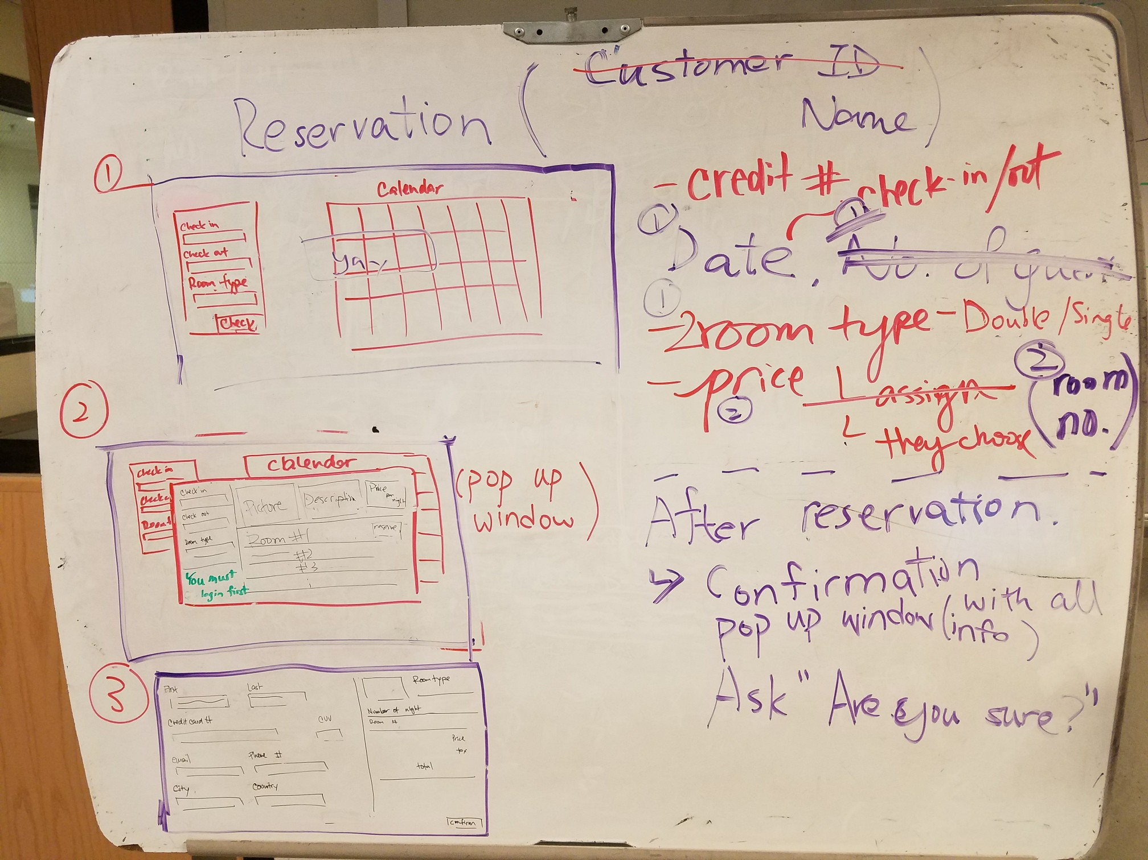

However, we only managed to implement part of the planned layout. The major elements, namely the input room type,check-in, and check-out date, as well as the calendar on the left, that the original reuse had were kept for the first reservation page (Fig a). It is user-friendly to input a check-in and check-out date by selecting the date using the calendar. We added a visitor view (Fig b) where visitors are not required to enter customer id number, so they are able to view the availability of rooms without having an account.

For the second step after clicking the Find Available Rooms, users can view all the available rooms (Fig c), then they have to choose the reservation type and input their credit card and CVV number if they have an account and plan to reserve a room.

A highlighted confirmation notice will appear if you click the room number from the previous page. This notifies the users that they have booked a room successfully.

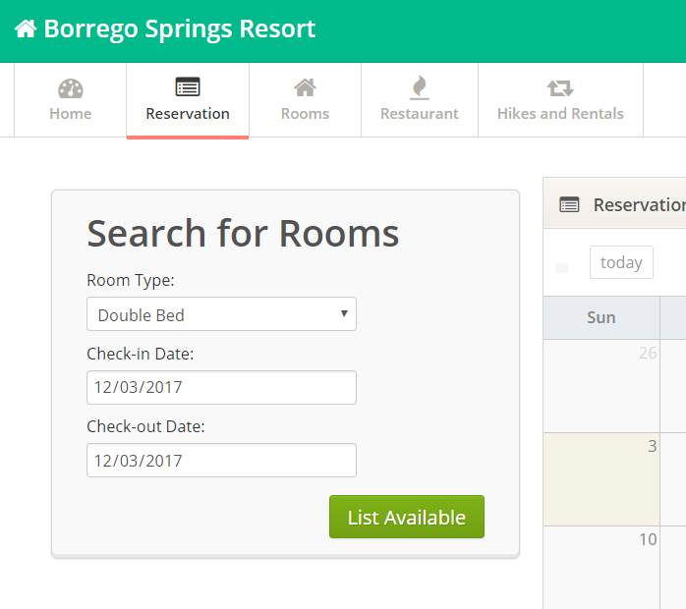 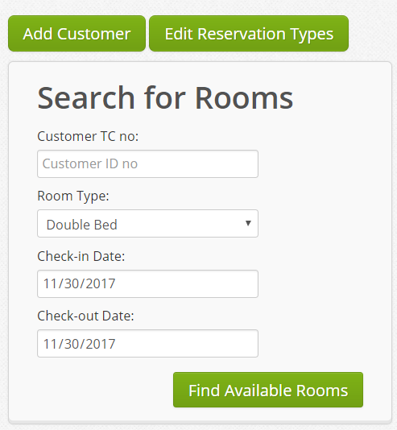

Fig a Employee view Fig b Visitor view

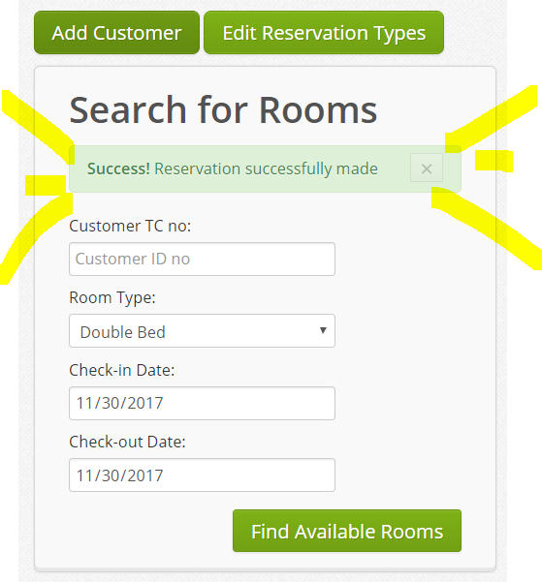

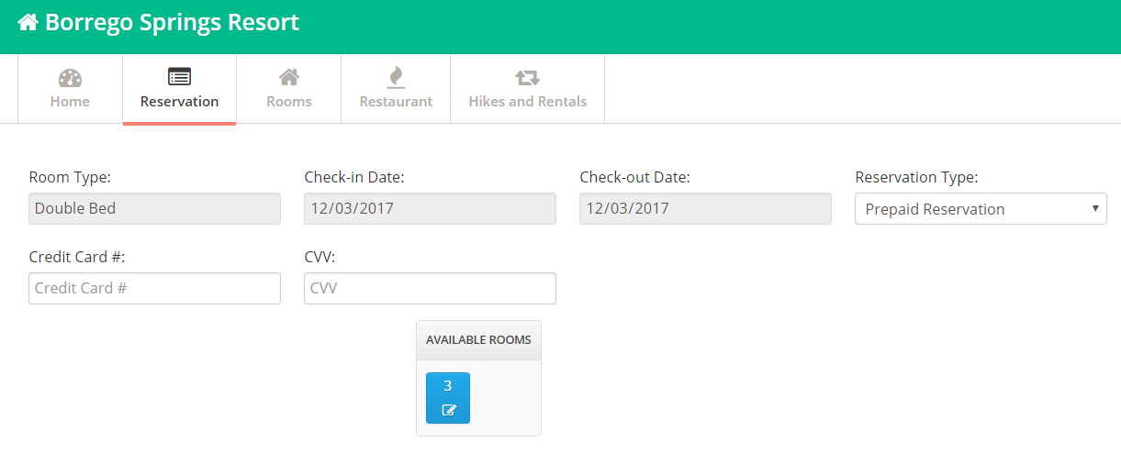

Fig c Available rooms Fig d Confirmation

**User stories**

For the landing page, we wanted the visitors and customers to know what is happening, especially for the visitors since, they are not logged in. These were some of the significant user stories that we attempted to implement in our project:

* As a visitor / customer, I want to:
  + view pictures of available rooms and room information so I can decide if I want to live in that room during my stay.
  + view room prices on the rooms page so that I’ll know how much I’ll be paying for
  + see announcements so that I’ll know if there is anything special happening at the resort.
  + browse the information of rooms, such as features, price, etc. on the landing page.
* As a customer, I want to:
  + remain logged into my account while accessing the landing page.

For the customer dashboard, we want to remind the users what they have reserved and/or rented in the resort. These were some of the significant user stories that we attempted to implement in our project:

* As a customer, I want to:
  + view my reserved room information (date, price, room type/number) so that I could easily access information on my room.
  + view my reservations for the restaurant so that I’ll have a reminder as to what sort of restaurant bookings I’ve made.
  + view my reservations for rentals and hikes (for the same reason above).
  + view my billing information of all reservations (for the same reason above).
  + log out so that I can maintain my account security.

For the reservation, different permissions were given to the visitors, customers, and employees. These were some of the significant user stories that we attempted to implement in our project:

* As a visitor, I want to:
  + check for availability for rooms so that I know what rooms and what types of rooms are available before I make a reservation
* As a customer, I want to:
  + make reservations from the landing page so that I can make a reservation.
  + make reservations from the customer dashboard when on the reservation page so that I can make a reservation.
* As an employee, I want to:
  + check for availability for rooms so that I know what rooms and what types of rooms are available before I make a reservation.
  + browse information of customers so that I can make reservation for them

**Test Plan Overview**

For the landing page feature, we created a test plan with the objective of testing the page layout in terms of access to each feature through user interface components and the ability to adjust window size without any problems. Using graph-based testing, we tested the project requirements of user interface performance and operational environment. The necessary input data is simply clicking on every user interface components such as tabs, buttons, and fields. The expected result is there should be no problems in accessing different pages (room, restaurant, and hikes) when we press on the respective tabs. The actual result is that we were successfully able to access the correct pages without any errors or bugs, making the result of this test plan a pass.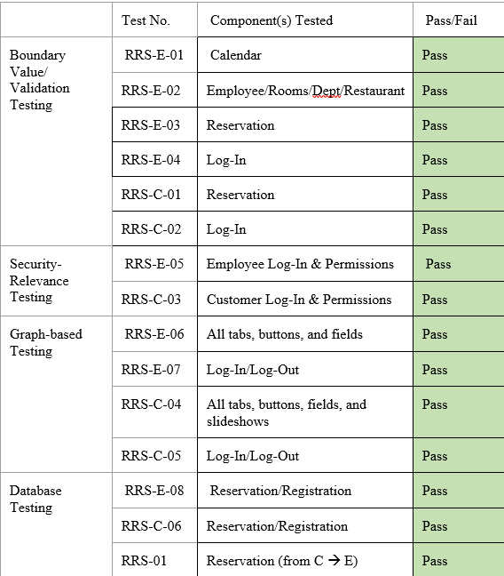

For the customer dashboard feature, we created a test plan with the objective of verifying a customer’s reserved room information displayed on the customer dashboard once successfully reserved. We used security relevance testing and database testing to verify the project requirements of security access, dashboard, and a database that supports multiple types of reservations, promotions, and costs. The necessary input data are the valid customer account has to be logged in and the valid customer account needs to have a room reserved. The expected result is we should only be able to view the dashboard once logged into the correct customer account. If a customer is not logged in, the system should prompt the user to log in to their account. The reservation information should also be correctly retrieved from the database and be displayed onto the customer dashboard page. The actual result is the correct room number, the check in date, and the check out date of reservation the customer made is displayed onto the customer dashboard page. We were able to successfully verify only if the customer has access to their reservation information on their dashboard, making the result of this test plan a success as well.

For the reservation feature, we created a test plan with the objective of verifying the functionality of reservation types and the ability to reserve a room. We used database testing and boundary value testing to test the project requirements of validation of inputs, error messages, support of multiple reservation types in the database, and reservation capabilities. The necessary input data are: (1) valid customer (which must be logged in), (2) valid/invalid calendar dates in the input fields, and (3) credit card number/CVV number. The prerequisite data that must be filled before these inputs are the rooms and reservation types, which the employee must populate the system within the database. The expected result is a customer should be able to view available rooms they can reserve once they select a date range to check in and out. The customer should then be redirected to a page to enter their credit card information and select an available room number to reserve from a given list. The cost of the room should be displayed and adjusts depending on the type of reservation type selected. Once a room number is selected, the system should prompt the user to confirm the reservation. Once confirmed, the user should be redirected to a page that displays reservation is successful. The actual result is a customer is able to successfully make a reservation if an available room is within the range of the check in/check out date, if the customer has entered the correct number of characters in the input fields, and if the customer has selected a room number. However, if an invalid date range is selected, the system displays there are “no available rooms” and that the reservation failed. While the user is able to successfully create a reservation, the reservation types does not impact the cost or the ability to make reservations. Because the reservation types is not fully implemented and the cost is not displayed, the result of the test plan ultimately fails.

**Overall Assessment/Lessons Learned**

The project went well from an overall perspective. Our team was able to fulfill the features that were negotiated with the customer for the most part. The landing page was successfully developed, but some information was hard coded in, such as the announcements and special discounts. We were able to implement customer reservations on the landing page, as well as information pages for the restaurant, different types of rooms, and hikes and rentals. The customer dashboard, customer registration and customer login was completed successfully. The reservations was fixed and connected to the database and we were able to add reservation types which was connected to the database. The customer reservations did have fields for the customer to input their credit card number and CVV number, but the backend was not implemented so that the data could be inserted into the database. However, this could be done in future iterations. Throughout our project we were able to meet weekly and because of that we were able to maintain good communication within the group, as well as assist team members who had questions or needed help. Furthermore, weekly meetings allowed the group to discuss about the project, raise any questions and address any issues that had emerged since the last meeting.

While the project went smoothly for the most part, we still did have some aspects of the project that went poorly and could have been reworked. One aspect was that the implementation phase started late because we were following the syllabus week by week. This caused some parts of the reservation feature, such as the backend component for the credit card number and CVV number, to not be implemented. In the end though, we were still able to implement and deliver the main functionality of the features requested by the customer. The other part of the project that could have been better was that tasks felt unorganized during the implementation phase. Sometimes it felt unclear who was working on what and what had already been finished. Our close communication helped alleviate this issue, but a project management application like Trello could have made things even clearer. This would have been something that we could do differently, if we were to do the project again.

Having a project management application like Trello would allow for the whole team to organize tasks and be on the same page during the development phase. Additionally, we could add estimates on how long a task would take and when we could expect it to be done. This would allow us to know when a task would be completed and estimate when we would be integrating a component, such as the reservations, into the landing page. Lastly, our team could have met with our customer more. We spoke to our customer about our plans and got our features approved, but between design and development we should have had at least one more meeting to show our progress and to ensure that our customer was happy with how the features looked at that time. In the end, the project was a major success and we were able to deliver our three new features while reusing open source software.